Name
STUDENT
HANDOUT

Welcome to the Airshed
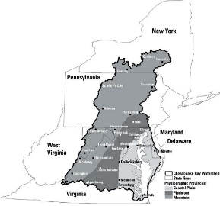
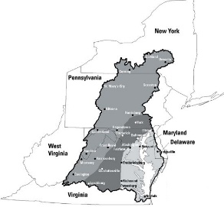

What is an airshed?

What is “dry deposition”?

What is “wet deposition”?

Conclusions

What did you learn from this activity about how air pollution gets into the Chesapeake Bay?

