Name
STUDENT
HANDOUT

Where is the Pollution Coming From?

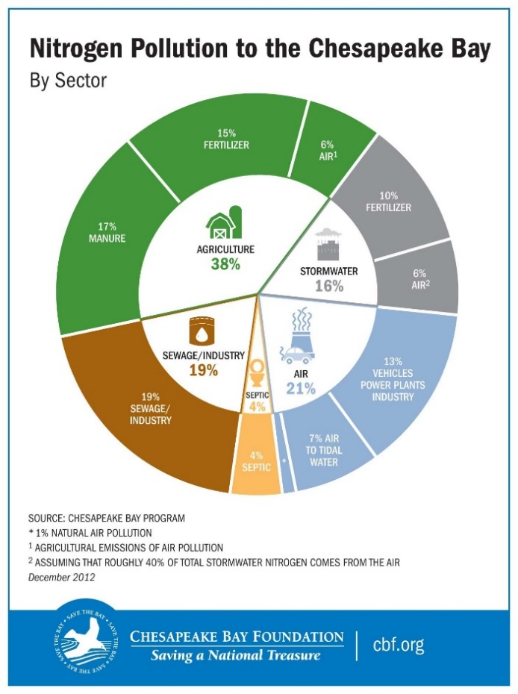
  - What sector (ex. sewage/industry, air, etc.) does the largest portion of nitrogen pollution to the Bay come from?

  - What percentage of the nitrogen pollution to the Bay comes from fertilizer? (make sure to look in all sectors):

  - What percentage of nitrogen pollution to the Bay is air pollution? (make sure to look in all sectors):

  - How do you think nitrogen pollution from things like fertilizer and manure gets into the Bay?

  - How do you think nitrogen pollution from things like sewage and industry gets into the Bay?

Conclusion
Do you think most of the nitrogen pollution in the Bay is dumped there intentionally? Use information from the infographic to support your answer.

