Name
STUDENT
HANDOUT

Sunny Day Floods

    - Using your computer, go to http://coast.noaa.gov/slr. This is the National Oceanic and Atmospheric Administration (NOAA) website for sea level rise. Click “Get started” to begin.

    - At the top of the page, where it says, “Enter an address or city” type in Annapolis, MD and click on it when it pops up.

Look at where Annapolis is. What is the area around Annapolis like?

High Tide Flooding
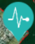
    - On the left side of the map, click “High Tide Flooding.” A little heartbeat icon will pop up next to Annapolis that looks like this: Click on the icon to learn more about how much flooding happens in Annapolis. If you move your cursor over the graph, you can get information for specific years.

    - What year had the most flood days in Annapolis? How many?

    - What is the greatest number of flood days in Annapolis in one year before 1983?

    - Look at the years 2010-2017. What is the range of the number of flood days per year (the range is the lowest amount to the highest amount) (lowest) - (highest)

    - What is the mean (average) number of flood days per year from 2010-2017? To find the mean, add up the total number of flood days from 2010-2017 and divide by the number of years. The average number of flood days from 2010-2017 is:

    - Do you think flooding in Annapolis is getting worse or not? Explain your answer using information from the graph.

Local Scenario
    - On the left side of the map, click “Local Scenarios.” A little house icon will pop up next to Annapolis that looks like this: Click on the icon to start the local scenario.

    - A box like the one below will pop up on the left. You can move the sliders on either side of
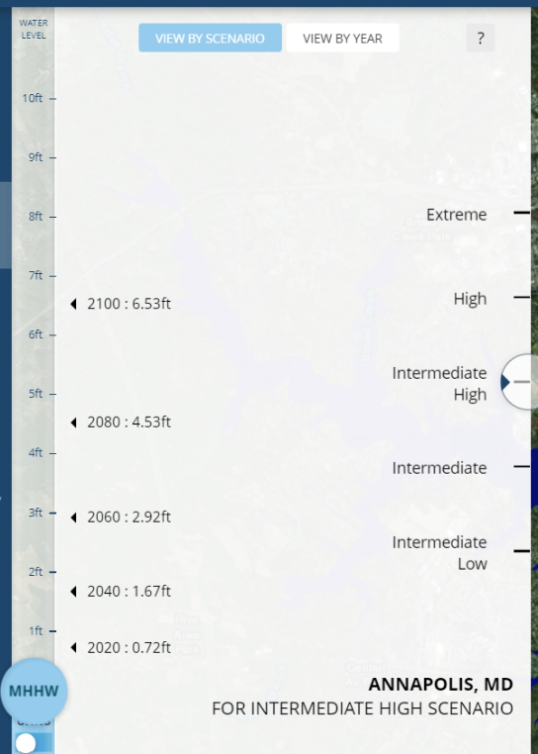
the box to change how high and how fast the ocean is rising. Zoom in using the + button in the bottom right to see Annapolis up close. Then try moving the sliders and seeing how the map of Annapolis changes.
Height of sea level rise for different years
MHHW is how high the water gets
How fast the ocean is rising

    - What happens to Annapolis if you raise the sea level up to 10 feet? (what do you think the light blue means?)
    - Move the slider on the right to “Intermediate High.” This means that the ocean is rising a medium amount. Now look at the left side of the box. In what year will the ocean be 2.92 feet higher?
Move the left slide to 3 feet. How bad is the flooding in Annapolis in this scenario?
    - Now move the slider on the right to “Extreme.” This means the ocean is rising a lot. Now how high will the water be in 2060?
Move the slider on the left to 5 feet. How bad is the flooding in Annapolis in this extreme scenario in 2060?

Vulnerable Places
Vulnerable places are those places that are in the most danger from sea level rise. Choose one or more of the vulnerable places below to investigate and circle the location on your paper. Use the search bar above the map to find the location.

Tangier, VA Ocean City, MD Toddville, MD Lewes, DE

    - When you are centered on the location, click on the “Sea Level Rise” button on the left and set the water level to “Current MHHW.”

Where is your location (ex: Is it an island? Is it at the beach? Is it on the coast?)

    - What does your location look like (is it flooded or dry land)?
Move the slider up to raise the sea level. How far do you have to go before the area is mostly underwater?
    - Find the nearest picture by clicking on a water drop that looks like this: You may need to zoom out to find it. When you click on it, set the water level to MHHW. What do you see?
Try moving the slider up to 3 feet, 7 feet, and 10 feet. What does the location look like now?
What would it be like if you were there?
    - Do you think the people in your vulnerable area should be worried about sea level rise? Why or why not?

My Home
    - Put your town into the bar above the map and use the tools you have learned about today to see if your community will be directly affected.
Will your community be flooded by sea level rise?
Why might you care about sea level rise even if your community is not directly flooded?

Summary
- What is causing the sunny day floods?
- What areas are most affected by sea level rise?
- What do you expect will happen to the number of sunny day floods if sea levels continue to rise?
- Imagine you are a business owner on a street near the harbor in Annapolis. How do you think your business will be affected by sunny day floods?

