Name
STUDENT
ASSESSMENT

Earth in 2050

Imagine that it is the year 2050. You are a professional climate scientist who specializes in studying sea level rise. You have been collecting and analyzing data on how much the ocean has risen since 2000. According to your measurements, the sea level has risen by 0.2 meters since 2000 (8 inches). You would like to use this information to think about how the Earth has changed in the last 50 years, and what humans have been doing to prevent climate change.

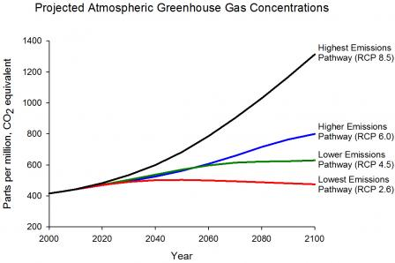
Use this information and the graphs below to answer the questions on the following pages.

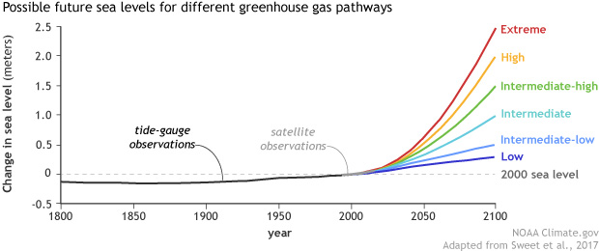

- Based on the amount of sea-level rise, what pathway (scenario) for sea level rise do you think happened (extreme, high, intermediate, or low)?

How did you find your answer?

- Based on the pathway you think happened, what do you think the concentration of greenhouse gases in the atmosphere is in 2050?

How did you find your answer?
- Sea level rise is an effect that has many causes. Fill in the boxes in the cause-effect chain below to show how human activities have led to rising sea levels.

Human activities like…

produced
which
caused

Sea levels to rise
This Photo by Unknown Author is licensed under CC BY

which
caused
which
caused

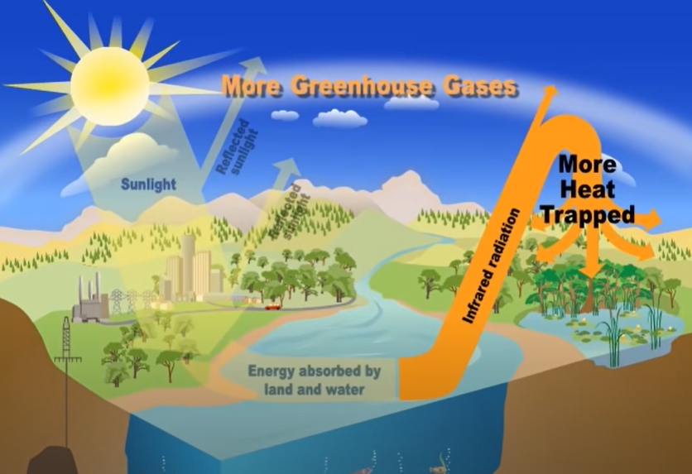
- The greenhouse effect is closely related to climate change. Use the diagram below to write an explanation of how the greenhouse effect works:

- What are humans doing that increases the greenhouse effect?
- Based on the pathway (scenario) that humans followed, what kinds of things do you think humans did to prevent climate change? Include at least three things in your answer.

- The Baltimore city government calls you to ask if they should be worried about rising sea levels. Look at the map below that shows a section of Baltimore.

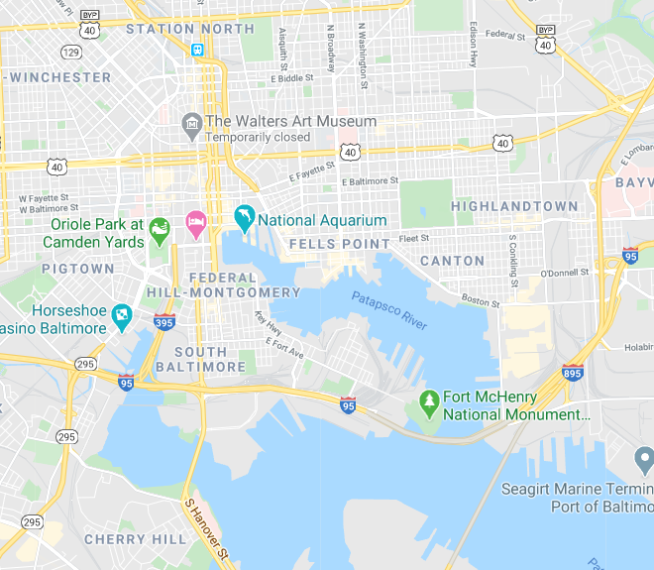
Which neighborhood is most at risk for rising sea levels? (1, 2, or 3)?
2
3
1

Why are they most at risk?

- The community you identified calls you to ask what they can do to make their neighborhood more resilient to rising sea levels. What suggestions would you make to them? Include at least two suggestions in your answer.

