Name
ANSWER GUIDE

Earth in 2050

Imagine that it is the year 2050. You are a professional climate scientist who specializes in studying sea level rise. You have been collecting and analyzing data on how much the ocean has risen since 2000. According to your measurements, the sea level has risen by 0.2 meters since 2000 (8 inches). You would like to use this information to think about how the Earth has changed in the last 50 years, and what humans have been doing to prevent climate change.

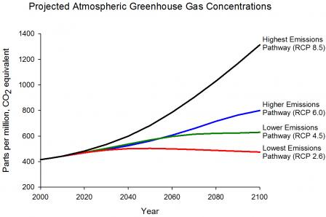
Use this information and the graphs below to answer the questions on the following pages.

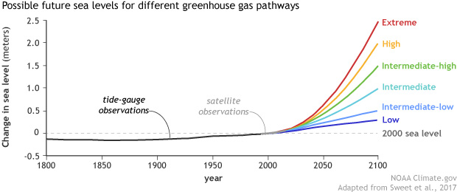

- Based on the amount of sea-level rise, what pathway (scenario) for sea level rise do you think happened (extreme, high, intermediate, or low)?

Low

How did you find your answer? I looked at the first graph and found the sea level rise for 0.2 meters on the y-axis. I went across to 2050, and saw that it intersected with the graph for the low pathway

- Based on the pathway you think happened, what do you think the concentration of greenhouse gases in the atmosphere is in 2050?

500 ppm

How did you find your answer? I looked the bottom graph, and found where 2050 was on the x-axis. I went up to the lowest emissions scenario and then across to the y-axis. It was about in the middle of 400 and 600ppm, so I estimated it was 500 ppm.
- Sea level rise is an effect that has many causes. Fill in the boxes in the cause-effect chain below to show how human activities have led to rising sea levels.

Human activities like…

Burning fossil fuels to make energy
Driving gas-powered cars
Greenhouse gases like carbon dioxide
Global temperatures to rise (increased the greenhouse effect)

produced
which
caused

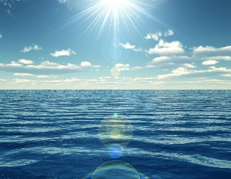
Sea levels to rise
This Photo by Unknown Author is licensed under CC BY
Land ice to melt (and thermal expansion of ocean water)

which
caused
which
caused

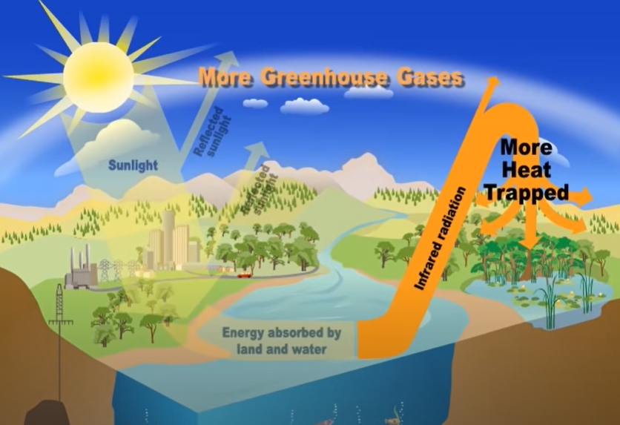
- The greenhouse effect is closely related to climate change. Use the diagram below to write an explanation of how the greenhouse effect works:

Sunlight from the sun heats up the Earth (land and water). The Earth then sends some of that heat back out into the air. Some of the heat goes back out into space, but some of it is trapped by greenhouse gases, which keeps the Earth warm.
- What are humans doing that increases the greenhouse effect? Humans produce more greenhouse gases when they burn fossil fuels for energy or transportation. This increases the greenhouse effect.

- Based on the pathway (scenario) that humans followed, what kinds of things do you think humans did to prevent climate change? Include at least three things in your answer.

Used more clean transportation (electric vehicles, mass transit, bicycles) Ate more locally-produced food and less meat Used energy more efficiently (turned off lights, electronics, etc.) Used more clean energy sources (wind, solar, geothermal, tidal) Many other answers possible

- The Baltimore city government calls you to ask if they should be worried about rising sea levels. Look at the map below that shows a section of Baltimore.

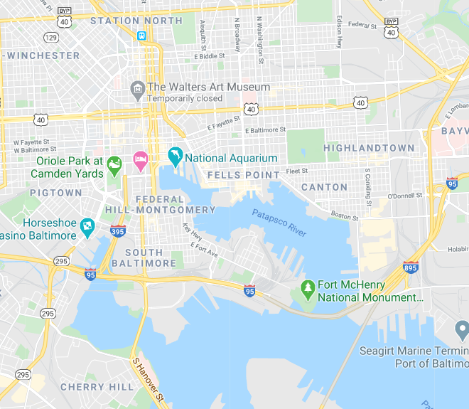
Which neighborhood is most at risk for rising sea levels? (1, 2, or 3)?
2
3
1

2

Why are they most at risk? It is closest to the water, and likely the lowest in elevation.

- The community you identified calls you to ask what they can do to make their neighborhood more resilient to rising sea levels. What suggestions would you make to them? Include at least two suggestions in your answer.

build walls at the water’s edge to prevent flooding create low-lying grassy areas with plants that will help to absorb floodwaters create channels to direct flood water back to the harbor build new buildings that have a ground floor that is above ground level) other creative answers are possible

