Name

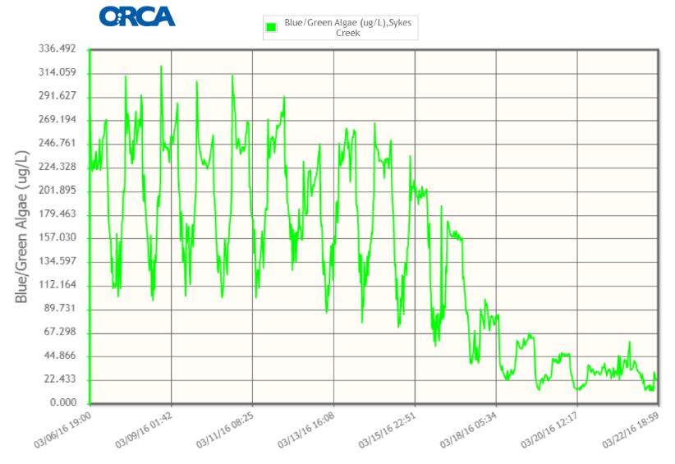
Blue-green Algae at Sykes Creek
Graph 1: Blue-Green Algae at Sykes Creek
STUDENT
HANDOUT

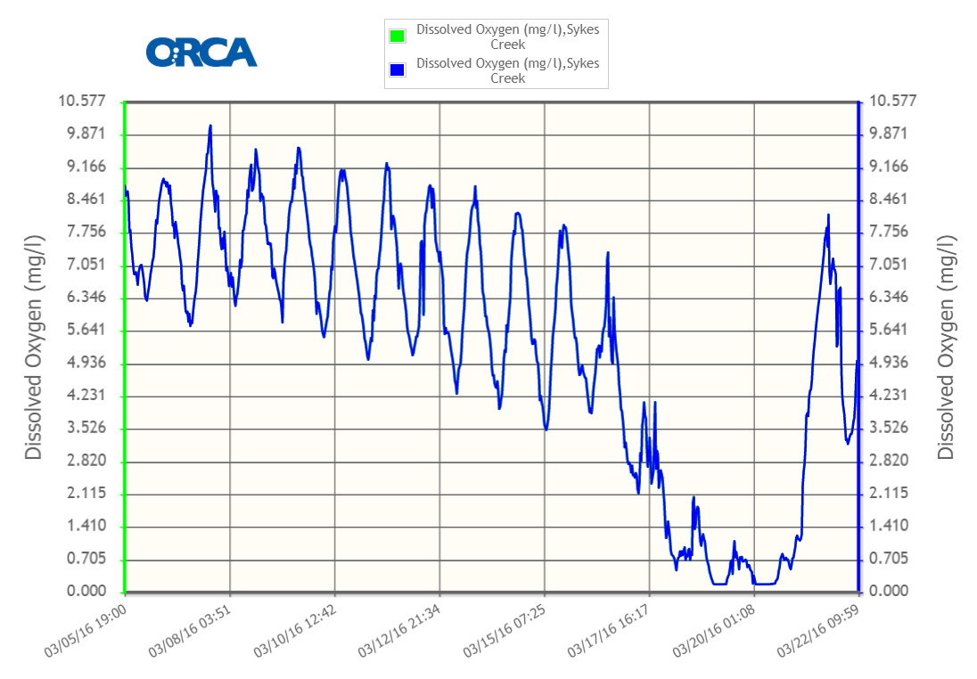
Graph 2: Dissolved Oxygen at Sykes Creek
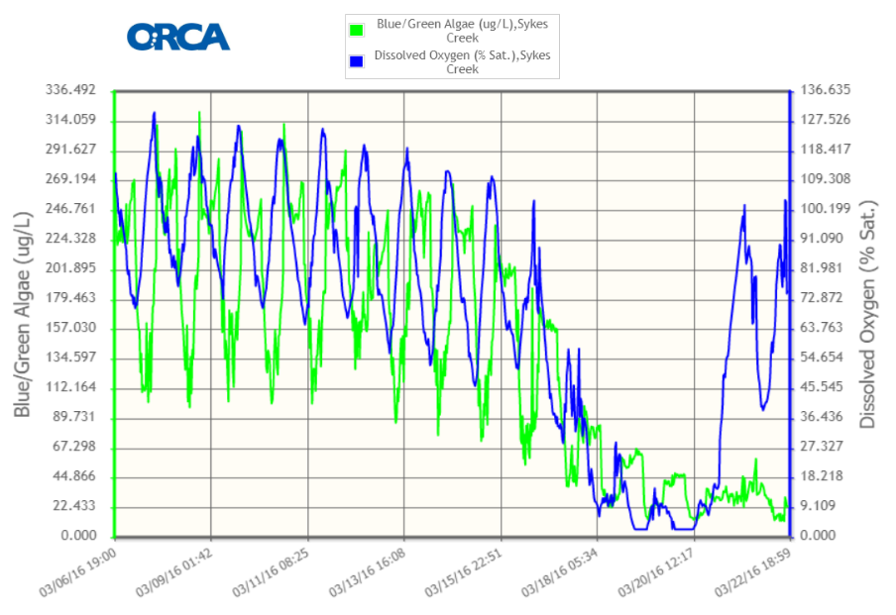
Graph 3: Blue-green Algae and Dissolved Oxygen at Sykes Creek

Conclusion
Explain what happened on March 20th in Sykes Creek using what you learned today from the graphs and the reading about algae and dissolved oxygen.

Name
STUDENT
READING

Algae & Dissolved Oxygen

Algae are living things that grow in all different kinds of water around the world. If you have ever looked at a pond and seen green scum on top, you’re looking at algae! Algae can be very small, single-celled organisms, or they can be large multicellular organisms. Algae can also clump together to form thick mats which can completely cover the surface of a lake or pond. They can also grow into big “forests” in the ocean. | Have you ever seen algae before? Where?
There are many different kinds of algae. There is also a bacteria, called blue-green algae, which is not algae at all! It just gets its name because it has many similar characteristics as algae.  The most common characteristics of algae are: they live in all types of water (freshwater and saltwater) and they conduct photosynthesis. This means that they can use sunlight to make their own food, just like plants. However, unlike plants, algae do not have roots stems, or leaves. | What are common characteristics of algae?
Photosynthesis makes food, and it also produces oxygen. When algae make oxygen, it is often dissolved in the water. When something is dissolved in water, it means it is mixed in with the water molecules. For example, if you stir sugar into a glass of iced tea, the sugar will dissolve into the tea. Dissolved oxygen is oxygen that is mixed into the water. Fish, crabs, shrimp, and other animals that live in water need the dissolved oxygen to breathe, just like we need oxygen in the air to breathe. | Where does the oxygen go that algae make?
Algae can help add oxygen to the water, but sometimes there can be too much algae. This is called an algae bloom. During an algae bloom, the algae blocks the sunlight from getting into the water. This causes the algae and underwater plants to die. When the algae die, decomposers like bacteria and fungi break down the algae. This uses oxygen. When there is a lot of dead algae, the decomposers use a lot of dissolved oxygen up from the water. | What do you think happens to the amount of dissolved oxygen in the water if there is too much algae?

