Group Names
STUDENT
EXPERIMENT

What is Causing the Ocean to Rise?
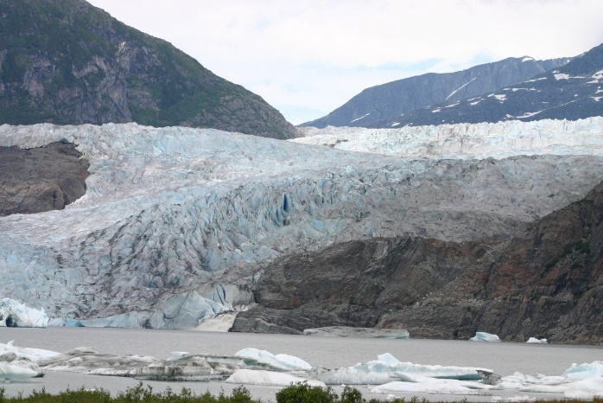
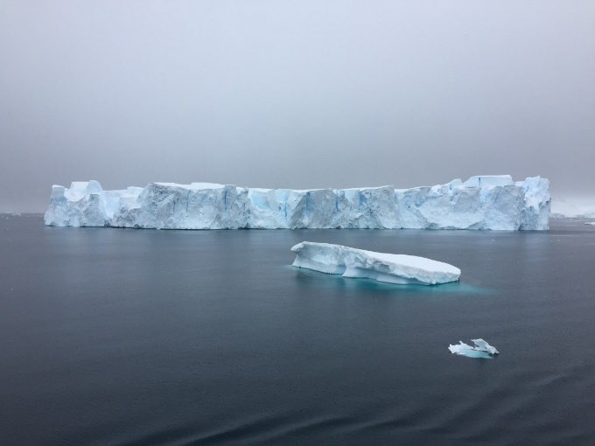

Type of ice: Type of Ice:

Found in: Found in:

Research question:

Materials

Experimental Design
In the space, draw a picture of what your land ice setup will look like, and what your sea ice setup will look like:
Land ice | Sea ice
Variables & Controls
What is your independent variable? (What are you changing between your two setups?)
What is your dependent variable (What are you measuring?)
What are you controlling (What needs to be the same in both of your setups?)
Data
How will you measure your sea level rise?
What units will you use?

Hypothesis
Do you think the land ice or sea ice will make the water rise higher? (you can also say they will rise the same amount)

Use the table below to record your data:

 | Land Ice | Sea Ice

Analysis
What does your data show? (how much did each water level change? which rose more? By how much?)

Conclusion

Was your hypothesis correct?

Why did the water rise more in one container than the other?

What kind of ice melting is causing sunny day flooding? Explain how you know using the result of your experiment:

