Name

I See & Hear, I Think, I Wonder…
STUDENT
HANDOUT

The Chesapeake Bay

Source | I See & Hear | I Think | I Wonder
Video
Map &
Reading

I See & Hear, I Think, I Wonder…
TEACHER
GUIDE

The Chesapeake Bay

Source | I See & Hear | I Think | I Wonder
Video | - Towns  - Brown water  - Bridges  - The shoreline would stretch to the west coast and back  - Potomac  - James  - Lighthouses  - Farms  - Marshes | - The Potomac is a river that goes into the Bay  - The water is dirty  - There is a bridge that goes over the Bay that leads to Ocean City | - How far away is the Bay from school?  - Is the water really dirty?  - What lives in the Bay?
Map &  Reading | - The Bay is between Maryland, Delaware, and Virginia  - The Bay looks like a big chicken finger  - The Chesapeake Bay is long and skinny  - The Chesapeake Bay is mostly north & south | - There are lots of different animals in the Bay like crabs, fish, and birds.  - There are lots of plants in the Bay  - The Bay is an estuary (salty and fresh water)  - The Bay is mostly shallow  - The Bay is very long (200 miles)  - The Bay is connected to the Atlantic Ocean  - Many rivers flow into the Bay  - The Bay is polluted | - Can you swim in the Bay?  - Can you drink the water?  - Where does pollution in the Bay come from?

Name
STUDENT
HANDOUT

About the Chesapeake Bay
The Chesapeake Bay is a 200-mile-long body of water that connects many rivers in Maryland Washington D.C., and Virginia to the Atlantic Ocean. In fact, the Chesapeake Bay watershed – the area of land that drains its water into the Bay, includes 6 different states and Washington, D.C.! The Chesapeake Bay is an estuary, which means that it is a place where freshwater and salt water mix. More than 50 major streams and rivers flow into the Bay.

Many different living things depend on the Chesapeake Bay. More than 3,000 species of animals and numerous species of plants live in the Bay or use it for food or shelter. Blue crabs and oysters are probably the most famous animals in the Bay, but many birds, like pelicans and osprey live there too. So do rockfish, river otters, and diamondback terrapin turtles. Underwater grasses and algae are also very important parts of the Chesapeake Bay ecosystem.
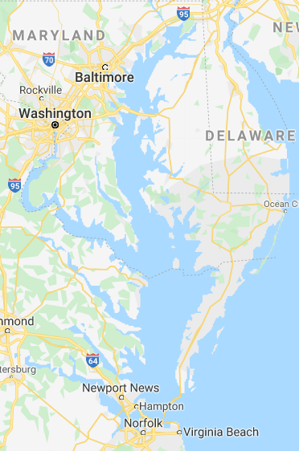

The Chesapeake Bay is not very deep in most places. The average depth of the Bay is 21 feet, although the deepest point is 174 feet. However, because it is so big, the Bay can hold more than 15 trillion gallons of water.

The Chesapeake Bay is very important to humans for many reasons. 10 million people live along the shore of the Bay or nearby and use it for recreation, food, and work. We harvest more than 500 MILLION pounds of seafood from the Bay every year!

The Chesapeake Bay also has a pollution problem. In 2019, the Bay got a score of C- for its health. That means we all need to do what we can to help make the Bay healthy and safe again.

Source: Chesapeake Bay Foundation, Geography and facts: https://www.cbf.org/about-the-bay/chesapeake-bay-watershed-geography-and-facts.html

