Ground-Level Ozone Trends

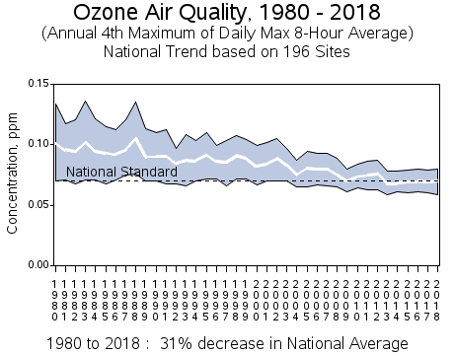
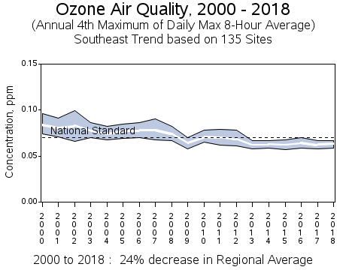
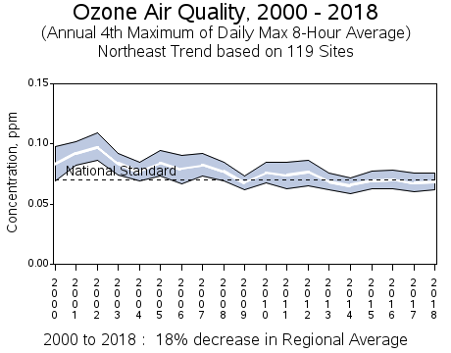
Northeast: ME, NH, VT, MA, RI, CT, NY, NJ, PA, DE, MD Southeast: VA, NC, SC, AL, GA, FL

Source: https://www.epa.gov/air-trends/ozone-trends
Carbon Monoxide Trends

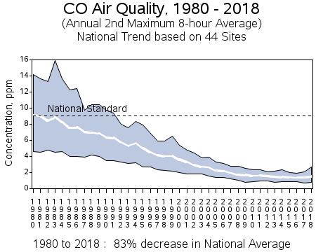

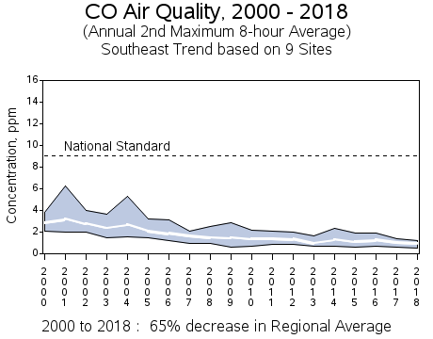
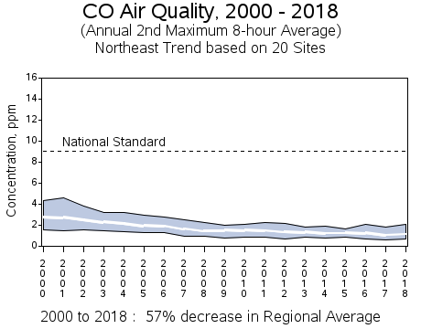

Northeast: ME, NH, VT, MA, RI, CT, NY, NJ, PA, DE, MD Southeast: VA, NC, SC, AL, GA, FL

Source: https://www.epa.gov/air-trends/carbon-monoxide-trends
Nitrogen Dioxide Trends

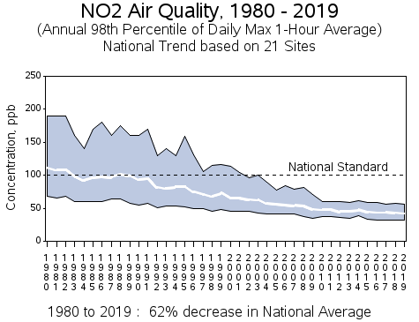

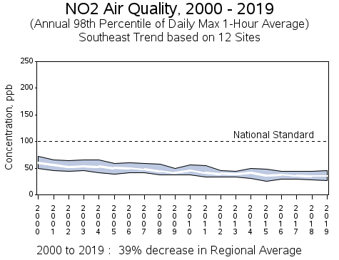
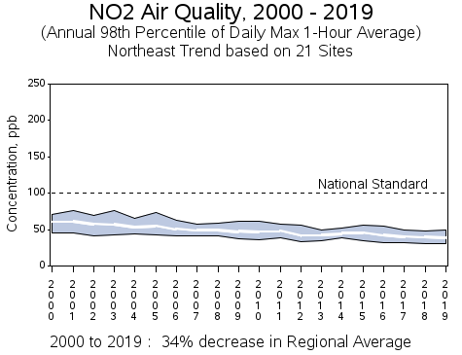

Northeast: ME, NH, VT, MA, RI, CT, NY, NJ, PA, DE, MD Southeast: VA, NC, SC, AL, GA, FL

Source: https://www.epa.gov/air-trends/nitrogen-dioxide-trends

Sulfur Dioxide Trends

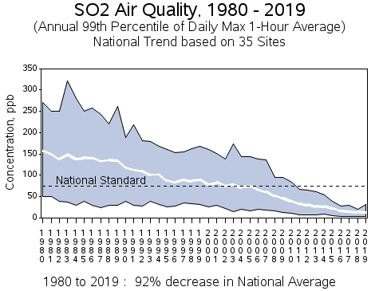
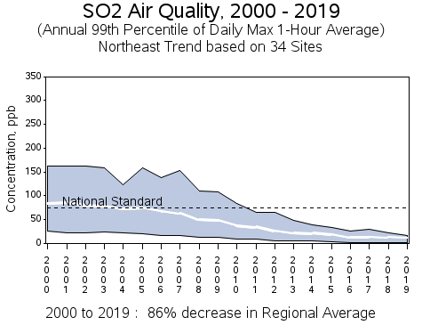
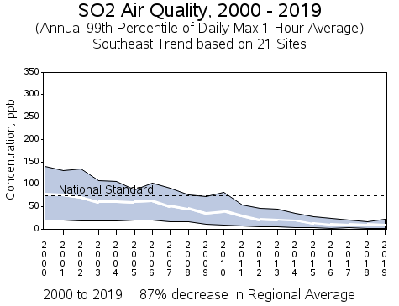

Northeast: ME, NH, VT, MA, RI, CT, NY, NJ, PA, DE, MD Southeast: VA, NC, SC, AL, GA, FL

Source: https://www.epa.gov/air-trends/sulfur-dioxide-trends

Particulate Matter 2.5µ Trends

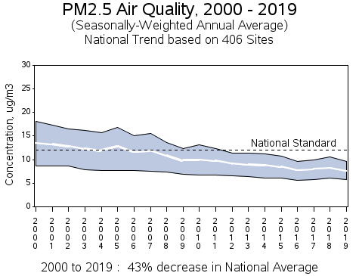

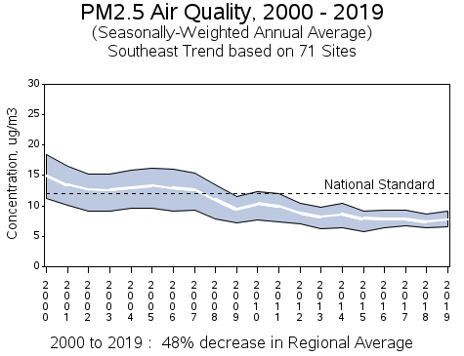
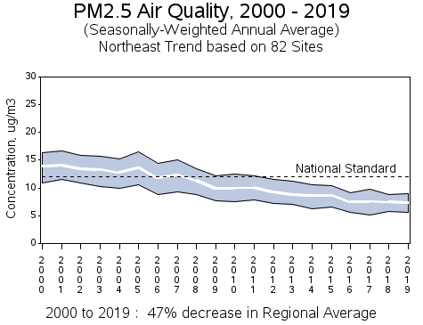

Northeast: ME, NH, VT, MA, RI, CT, NY, NJ, PA, DE, MD Southeast: VA, NC, SC, AL, GA, FL

Source: https://www.epa.gov/air-trends/particulate-matter-pm25-trends

Lead Trends

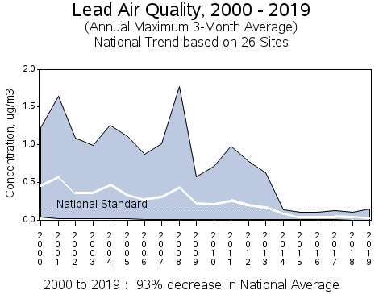

Source: https://www.epa.gov/air-trends/lead-trends

