Name
STUDENT
HANDOUT

What Happens When Things Burn?

Candle
Observations | Explanations

Combustion:

Incomplete combustion:

Particulate matter:

Materials needed for combustion | Products of incomplete combustion
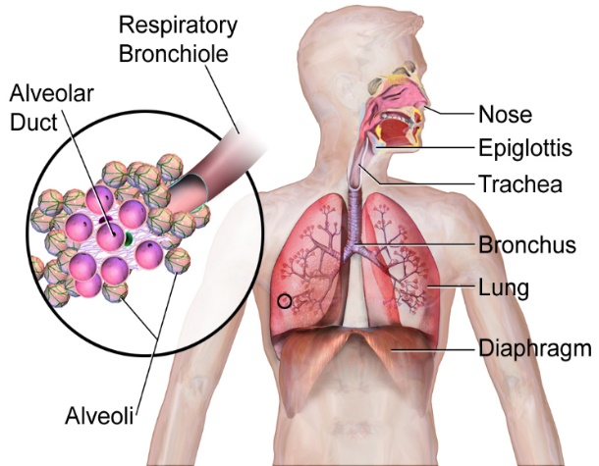
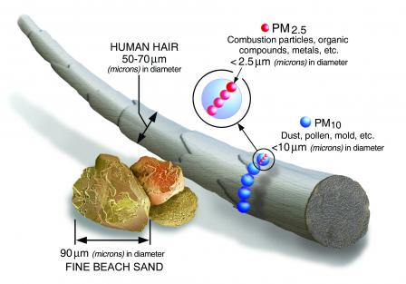
What else is a fuel? What burns?

Reading
Particulate matter is one kind of air pollution that is a product of combustion. Large particulate matter or PM 10 is made of things like dust, pollen, soot and other chemicals. PM 10 is between 2.5 micrometers and 10 micrometers long. That is about one-fifth the width of a human hair. Small particulate matter or PM 2.5 is smaller than 2.5 micrometers. That means four particles of PM 2.5 are about the same length as one particle of PM 10. PM 2.5 is a mix of chemicals and metals that are very tiny. PM 2.5 is so small, you can only see it if there is a lot of it in one place. The funny symbol µ in the diagram above stands for “micro.” One µm (micrometer) is 1/1000000th of a meter (one millionth) or 1/1000th of a millimeter. That’s really small! Particulate matter can be a solid or a liquid, depending on the source of the pollution. All particulate matter is dangerous to human health when we breathe it into our lungs. PM2.5 is especially hazardous because it can go deep into the alveoli of our lungs and may even cross into our bloodstream and affect all parts of our bodies.

Name two similarities and two differences between PM10 and PM2.5
Similarities | Differences

