Name
STUDENT
HANDOUT

Air Pollution Summary

Pollutant | What is the EPA limit for this pollutant? | How has the amount of this pollutant changed since 1980? | What was the level of this pollutant in 2018? | Is this pollutant still a problem where we live?
Ground-level Ozone
Carbon monoxide
Nitrogen dioxide
Sulfur dioxide
Particulate matter 2.5 |  | (since 2000 for this graph)
Lead |  | (since 2000 for this graph) |  | Use national graph data
STUDENT
HANDOUT

Name
STUDENT
HANDOUT

How Much Pollution Is Too Much?

The United States Environmental Protection Agency (EPA) is a part of the government that is responsible for making sure the air we breathe is safe. Scientists at the EPA decide how much pollution in the air is harmful to human health or the environment. It would be safest if there were no pollution in the air at all, but many of the things we like to use such as cars and computers either make pollution, or use electricity that is often made in way that creates pollution. For example, gasoline-powered cars create air pollution, and power plants that burn fuel to make electricity also make air pollution.

The EPA sets limits for the amount of air pollution that is harmful people to breathe into their lungs. There are different limits for each kind of air pollution based on how harmful each kind of pollution is. Very harmful pollutants have very low limits because even very, very small amounts of these chemicals can be harmful. The units that the EPA uses for these limits are “parts-per-million” or ppm and “parts-per-billion” or ppb. These are units just like inches or miles or meters. One part-per-million means one molecule of pollution in 1 million molecules of air.

How many is one part-per-million? Think how long one day is. One day in a million days is the same as one day in 2,737 years!

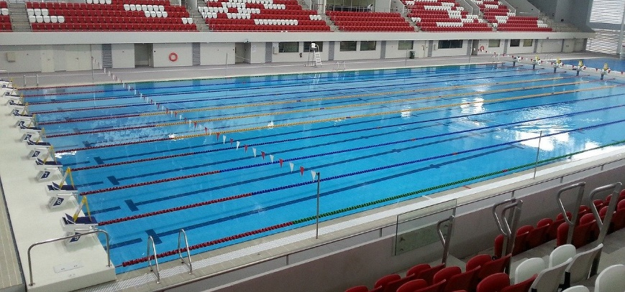
How about one part-per-billion? Imagine an Olympic-sized swimming pool like the one in the picture below. One part-per-billion is the same as one drop of water in the whole swimming pool.
One part-per-billion

We can also write units such as percent, parts-per-million and parts-per-billion as fractions to help compare them. Look at the three fractions below:

1 percent (1%) = $\frac{1}{100}$ 1 ppm = $\frac{1}{1,000,000}$ 1 ppb = $\frac{1}{1,000,000,000}$

One percent pollution would mean 1 molecule of pollution for every 100 molecules of air. 1 ppm is 1 molecule of pollution for every 1,000,000 molecules of air, and 1 ppb is 1 molecule of pollution for every 1,000,000,000 molecules of air.
Even though these amounts of pollution seem very small, they can have a big effect because humans breathe so much air. The average human breathes 10,000 liters of air a day, so even small amounts of pollution can cause a big problem for us.

How much pollution is too much? The EPA limits for a few common air pollutants are shown in the table below:

Pollutant | Limit of “safe” amount | Limit in fraction form
Sulfur dioxide | 75 parts-per-billion (ppb) | $$\frac{75}{1,000,000,000}$$
Nitrogen dioxide | 100 parts-per-billion (ppb) | $$\frac{100}{1,000,000,000}$$
Carbon monoxide | 9 parts-per-million (ppm) | $$\frac{9}{1,000,000}$$
Ozone | 75 parts-per-billion (ppb) | $$\frac{75}{1,000,000,000}$$

Compare the EPA limits for the four different pollutants listed. The write them in order from smallest to largest, using the symbols >, <, and =. Label each one using the ppm and ppb notation.

The average human breathes 10,000 liters of air a day (2,641 gallons). If you breathe 10,000 liters of air in a day, how many liters of ozone would you breathe in a year if the air had the EPA limit of ozone in it?

TEACHER
GUIDE

Compare the EPA limits for the four different pollutants listed. The write them in order from smallest to largest, using the symbols >, <, and =. Label each one using the ppm and ppb notation.

$$\frac{9}{1,000,000}>\frac{100}{1,000,000,000}>\frac{75}{1,000,000,000}=\frac{75}{1,000,000,000}$$

9pmm > 100 ppb > 75 ppb = 75 ppb

Carbon monoxide nitrogen dioxide sulfur dioxide ozone

The average human breathes 10,000 liters of air a day (2,641 gallons). If you breathe 10,000 liters of air in a day, how many liters of ozone would you breathe in a year if the air had the EPA limit of ozone in it?

$$\frac{10,000 liters of air}{day}×\frac{75 liters of ozone}{1,000,000,000 liters of air}×\frac{365 days}{year}=$$

$$0.27 liters of ozone per year$$

