Our Lungs, Our Air, Our Health Module Assessment
SCORING GUIDE

Teacher Scoring Guide

 |  | Points possible
Part 1 | Organs of the Respiratory System | 5
Part 2 | Modeling the Respiratory & Circulatory Systems | 15
Part 3 | The Human Body: A System of Systems | 5
Part 3 | Air pollution | 10
Total Points |  | 35

Part 1: Parts of the Respiratory System (5 points): One point for each correct answer
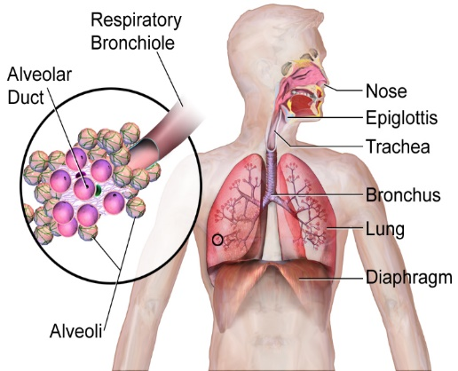
Source: https://upload.wikimedia.org/wikipedia/commons/e/e7/Respiratory_System_%28Illustration%29.png

Part 2: The Respiratory & Circulatory Systems (10 points)
Sample response:
- Oxygen enters the body through your nose and mouth when you breathe in. It travels down your trachea and into your lungs. When it reaches your alveoli, it goes out of the alveoli into your blood vessels. The heart pumps blood around the circulatory system. This caries the oxygen to all the cells of your body.
- The arrows go in two directions inside the body because oxygen is going to your cells from outside your body, and carbon dioxide is going from your cells to the environment in the opposite direction.

Points | Description
10 | Student thoroughly and accurately describes the path of oxygen from the environment to parts of the body, including accurate scientific terminology for parts of the respiratory and circulatory systems.  Student accurately explain why the arrows in the body go in two directions in the model.
8 | Student describes the path of oxygen from the environment to parts of the body, but does not use accurate scientific terminology or includes a minor error in the pathway OR  Student does not accurately explain why the arrows in the body go in two directions in the model
6 | Student’s description of the path of oxygen to parts of the body is partially correct but includes significant errors. Student does not accurately explain why the arrows in the body go in two directions in the model.
3 | Student’s description of the path of oxygen is incorrect and their answer does not explain why the arrows in the body go in two directions in the model.

Part 3: The Human Body: A System of Systems (5 points)
- Sample response: The human body is called a system of interacting systems because a person is a system: it has a bunch of parts that work together, and those things have a bunch of parts that work together. For example, we have a circulatory system and a respiratory system that work together. They also have parts that work together. They are interacting because they depend on each other. The respiratory system gets oxygen from the air and gives it to the circulatory system to deliver. When we did our experiment with breathing and heart rate, when my partner exercised, his heart rate and his breathing both went up because the systems are connected.

Points | Description
5 | Student’s explanation is accurate and provides a meaningful example from the module to support it. They either explicitly or through their explanation, define what a system is.
4 | Student’s explanation is mostly accurate and provides an example from the module to support it. They may or may not define what a system is.
3 | Student’s explanation is on topic, but does not make it clear how the human body is system of systems. The example from the module is connected to systems but does not show how the body is a system of systems. They may or may not define what a system is.
3 | Student’s explanation is incorrect and shows significant misunderstanding of the concept. They may or may not have an example from the module and may or may not define what a system is.

Part 3: Air Pollution (10 points)
Sample response:
- Model shows ozone entering the body through the nose and mouth, and affecting the lungs.
- Model shows PM 25. Entering the body through the nose and mouth, and affecting the lungs and “all cells of the body”.
- Air pollution can cause an asthma attack because when ozone gets into your lungs, it irritates your bronchi and bronchioles in your lungs. When this happens, your lungs make mucus to stop the irritation. The mucus can make it hard for you to breathe. It also makes you cough. These can cause an asthma attack to happen.

Points | Description
10 | Student accurately shows how pollution gets into the body and what parts of the body are affected by ozone and PM 2.5.  Student thoroughly and accurately describes how air pollution can cause an asthma attack using appropriate scientific terminology.
8 | Student has minor errors in either in the parts of the body that are affected by ozone and PM 2.5 OR in how air pollution can cause an asthma attack.
6 | Student’s response shows some understanding of how air pollution affects the body, but the response has significant errors in the parts of the body that are affected by ozone and PM 2.5 and in how air pollution can cause an asthma attack.
3 | Student’s response about how air pollution affects the body is mostly incorrect but shows some understanding.

