Name

Respiratory & Circulatory Systems

STUDENT

HANDOUT

[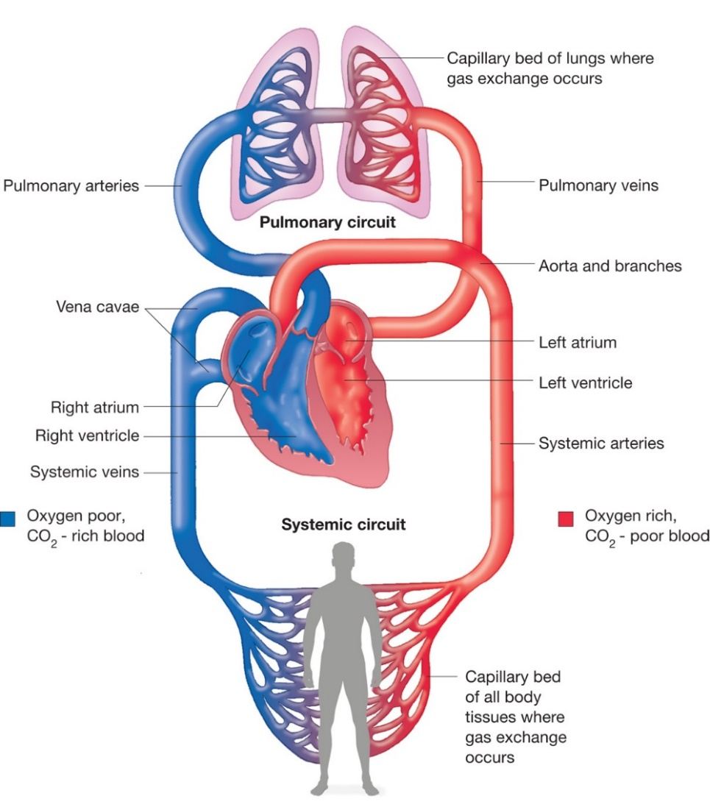](https://biology-forums.com/index.php?action=gallery&sa=view&id=8516)

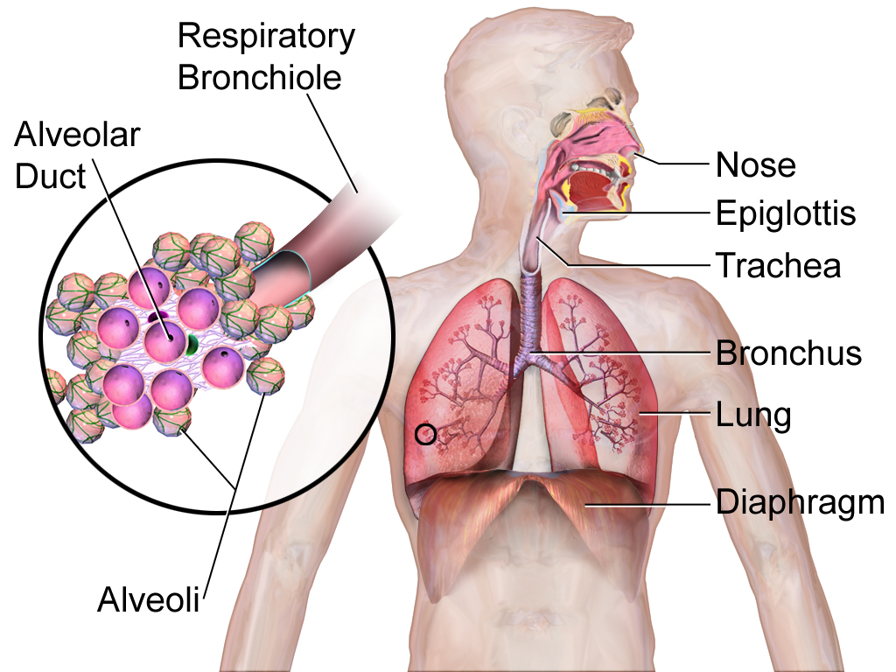

Compare & Contrast

Circulatory System

Respiratory System

Purpose:

Key parts:

Other important information:

Purpose:

Key parts:

Other important information:

Common purpose:

Crossover location (part):

When it is active:

Other information: