Name

The Air Quality Index
STUDENT
READING

What is the AQI?  The Air Quality Index or “AQI” is a tool used to report daily air quality. The AQI uses color-codes and a numerical scale to report how clean or polluted the air is and what associated health effects might be of concern. The AQI focuses on health effects people may experience within a few hours or days after breathing polluted air.  A different AQI is calculated for each of the major pollutants regulated by the Clean Air Act except for lead: particulate matter, ozone, carbon monoxide, sulfur dioxide, and nitrogen dioxide. The overall AQI for a day is equal to the worst AQI score for any of the 5 pollutants. For example, if the AQI for ozone is 52, and the AQI for PM is 86, then the overall AQI for the day is 86. | What are the two ways that the AQI reports air quality information?  How long might a person feel the effects of breathing polluted air?  What are the pollutants that are included in the AQI?
How Does the AQI Work?  Think of the AQI as a yardstick that runs from 0 to 300. The higher the AQI value, the greater the level of air pollution and the greater the health concern. For example, an AQI value of 50 represents good air quality with little potential to affect public health, while an AQI value over 200 represents very unhealthy air quality. An AQI value of 100 generally corresponds to the national air quality standard for the pollutant, which is the level the Environmental Protection Agency (EPA) has set to protect public health. | What AQI value matches with the EPA limit for a pollutant?

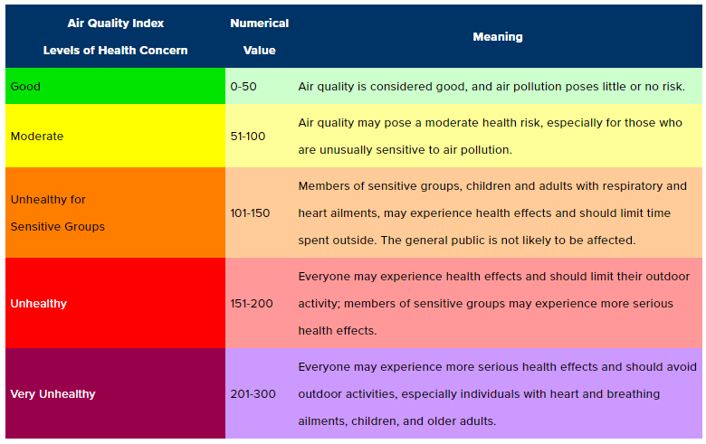
The Air Quality Index

AQI values below 100 are generally thought of as satisfactory. When AQI values are above 100, air quality is considered to be unhealthy – at first for certain sensitive groups of people, then for everyone as AQI values get higher. | What is the range of air quality that is unhealthy for everyone?  What do you think the level of Air Quality was on the Code Red day we read about?
Air quality can impact your day as much as the weather and traffic can — which makes checking daily air quality forecasts an equally important part of your routine. Visit the Clean Air Partners Current Air Quality webpage or download the Clean Air Partners Air Quality App to have air quality information at your fingertips. | How can you find information about the current AQI where you live?

Source: Adapted from Air Quality Index (Clean Air Partners) https://www.cleanairpartners.net/aqi

Name

TEACHER
GUIDE

The Air Quality Index

What is the AQI?  The Air Quality Index or “AQI” is a tool used to report daily air quality. The AQI uses color-codes and a numerical scale to report how clean or polluted the air is and what associated health effects might be of concern. The AQI focuses on health effects people may experience within a few hours or days after breathing polluted air.  A different AQI is calculated for each of the five major pollutants regulated by the Clean Air Act: particulate matter, ozone, carbon monoxide, sulfur dioxide, and nitrogen dioxide. The overall AQI for a day is equal to the worst AQI score for any of the 5 pollutants. For example, if the AQI for ozone is 52, and the AQI for PM is 86, then the overall AQI for the day is 86. | What are the two ways that the AQI reports air quality information?  As a color-code and a number.  How long might a person feel the effects of breathing polluted air?  For hours or days  What are the pollutants that are included in the AQI?  PM, ozone, carbon monoxide, sulfur dioxide, and nitrogen dioxide.
How Does the AQI Work?  Think of the AQI as a yardstick that runs from 0 to 300. The higher the AQI value, the greater the level of air pollution and the greater the health concern. For example, an AQI value of 50 represents good air quality with little potential to affect public health, while an AQI value over 200 represents very unhealthy air quality. An AQI value of 100 generally corresponds to the national air quality standard for the pollutant, which is the level the Environmental Protection Agency (EPA) has set to protect public health. | What AQI value matches with the EPA limit for a pollutant?  100
The Air Quality Index

AQI values below 100 are generally thought of as satisfactory. When AQI values are above 100, air quality is considered to be unhealthy – at first for certain sensitive groups of people, then for everyone as AQI values get higher. | What is the range of air quality that is unhealthy for everyone?  151-300  What do you think level of Air Quality was on the Code Red day we read about?  Red, unhealthy, 151-200
Air quality can impact your day as much as the weather and traffic can — which makes checking daily air quality forecasts an equally important part of your routine. Visit the Clean Air Partners Current Air Quality webpage or download the Clean Air Partners Air Quality App to have air quality information at your fingertips. | How can you find information about the current AQI where you live?  From websites (like the Clean Air Partners website) or using an app on your phone.

Source: Adapted from Air Quality Index (Clean Air Partners) https://www.cleanairpartners.net/aqi
Name
STUDENT
HANDOUT

Historical AQI Data Investigation

Directions
- Open a web browser and go to the Clean Air Partners website for historical air quality data: https://www.cleanairpartners.net/historical-air-quality
- Use the date dropdown menus to choose the date you are looking for
- Click on the date “details” to see a summary of the data for that date

Date #1: July 20, 2017
What was the AQI for this date?

What was the Particulate Matter (PM) AQI?

Where was the PM AQI the highest (what site name)?

What was the Ozone AQI?

Where was the Ozone AQI the highest?

Why was this a Code Red day in the area?

Date #2:
What was the AQI on this date? (color & number):

What pollutant had the highest AQI?

What was the AQI for this pollutant?

What recommendations would you make for people if you were an air quality expert on this day?

Date #3:
What was the AQI on this date? (color & number):

What pollutant had the highest AQI?

What was the AQI for this pollutant?

What recommendations would you make for people if you were an air quality expert on this day?

Date #4:
What was the AQI on this date? (color & number):

What pollutant had the highest AQI?

What was the AQI for this pollutant?

What recommendations would you make for people if you were an air quality expert on this day?

What pollutant or pollutants cause(s) the most bad air quality days in our area?

What was the cause of the Code Red Day from our article? (July 9, 2018)
What was the AQI for that pollutant on July 9, 2018?

Name
STUDENT
HANDOUT

AQI Through the Years

Look at the calendars below that show the AQI for the month of July every five years starting
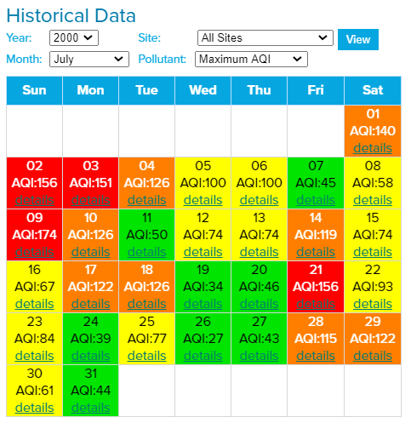
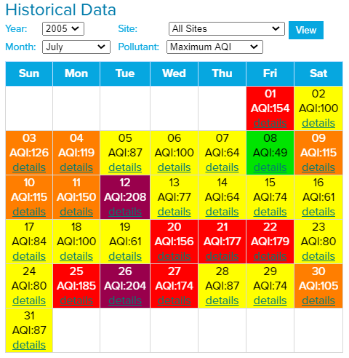
in 1995:
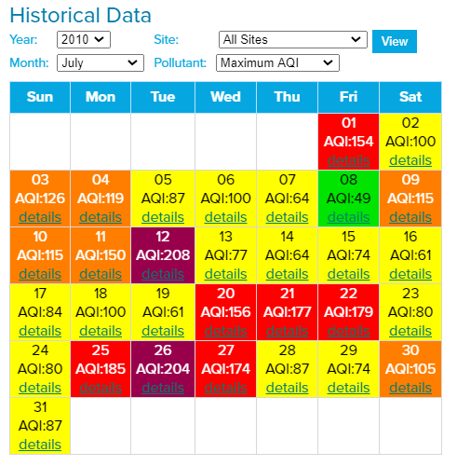
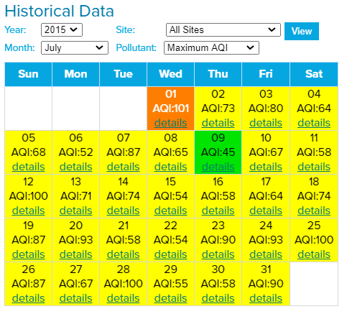
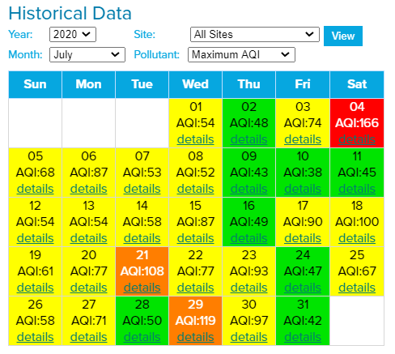
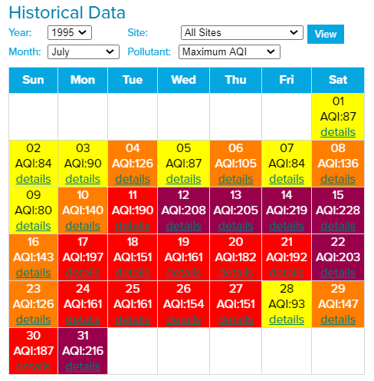
Use the information in these calendars to fill in the table below:

Year | Green Days | Yellow Days | Orange Days | Red Days | Purple Days
1995
2000
2005
2010
2015
2020
Data Analysis
Use the information in the table to look for trends in the data. In other words, how have the number of different AQI days changed over time for each color?

The number of green days has

The number of yellow days has

The number of orange days has

The number of red days has

The number of purple days has

Conclusions
Based on your data analysis, how would you say the level of air pollution in the Washington, DC area in July has changed since 1995? In your answer, be sure to use data and your analysis to support your conclusion.

