Name
STUDENT
GUIDE

Environmental Justice Investigation Guide

Directions:
- Using your computer, go to the EJScreen website: https://ejscreen.epa.gov/mapper/

- In the top right corner where it says, “Find an address or place” type in your city or town and click the name of the town when it pops up. You can also use your zip code for a closer map. You should see the map move to show your city or neighborhood.
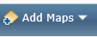
- Click the button at the top that says “Add Maps”. It looks like this:
From the dropdown menu, choose EJSCREEN Maps. A box will pop up that has a list of many different maps to choose from. Since we are studying particulate matter from trucks, click PM 2.5 and click “Add to Map”.

- The map you see now shows how the amount of PM 2.5 in your neighborhood compares to the amount in other parts of the country. Use the scale that popped up on the right side to match the color on the map with the percentile for your neighborhood. Write the percentile in the space below.

PM 2.5 in my neighborhood:

This means that your neighborhood has more PM 2.5 pollution than the same percent of neighborhoods around the country. For example, if your percentile is in the 80-90 range, then it means that 80-90% of the neighborhoods in the country have less PM 2.5 in their air than you do.

- Zoom out by clicking the minus sign in the top left of your screen. Keep zooming out until you can see all of Maryland, Virginia, and Pennsylvania. Do you see a big red spot of PM 2.5 pollution near Harrisburg? What do you think might be there?

- Change the map from PM 2.5 to Ozone by clicking Ozone in the box on the left and clicking “Add to Map”. Stay zoomed out so you can see the whole area. In what areas is ground-level ozone a problem?

Why do you think it’s a problem here? (hint: think about what people do a lot of in this area that might cause a lot of air pollution)
- In the box on the left-hand side, click “Demographic Indicators.” This will bring up a list of characteristics about people. Look at the maps for Minority Population and Low-Income Population. Where do you see high minority populations (people of color) and low-income populations?

- Zoom back in on the area where your school is (you may need to put the town back into the search in the top right). What can you tell about the demographics of the neighborhood around the school?

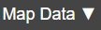
- At the top of the screen, click “Add maps” and then choose Side-by-Side maps. This will bring up two maps where you can look at different things at the same time. In the top left of the screen, click Map Data (it looks like this: ) and choose the Environmental Indicator for NATA Diesel PM. Then click Update Map. Diesel PM is particulate matter from vehicles like trucks that use diesel fuel. What do you notice about where Diesel PM is bad?

- On the right-hand map, click the Map Data button, and make sure the top button is on EJSCREEN Maps. Then choose Demographic Indicators and Demographic Index, and click Update Map. Demographic Index shows where people of color and low-income people live. Make sure you are zoomed out so you can see the whole DC-Baltimore area. Compare the two maps. Where are the colors the same in both maps?

If the colors are in the sample places it means that people of color and low-income people live in places where there is a lot of air pollution. This is a sign of environmental injustice. Environmental injustice means that some people are affected more by pollution than others in a way that is unfair.

- Go back to your original one map and in the pop-up on the left, choose EJ Indexes. EJ Indexes are like combining the two maps you just looked at into one map. If the colors on the map are in the yellow or red zone, it means environmental injustice may be happening in that community. Choose different pollutants for the EJ Index and click Add to Map. Which pollutants likely cause the most environmental injustice?

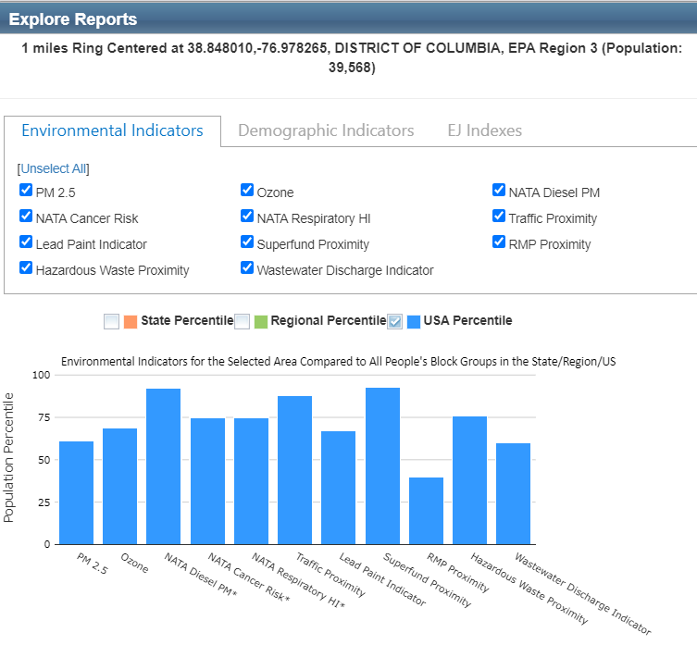
- Use the location search in the top right of the screen to go back to the neighborhood where your school is. Then click the “Select Location” button at the top of the screen. Click Select Location again from the dropdown menu. A little box will pop up. Make sure the little pin is selected, and then click on the map near where you think the school is located. A little box will pop up. In the box, click “Explore Reports”. This will bring up reports about environmental justice in the area that look like this:

Look at the data in the bar graphs. This shows the percentiles for all the pollution within 1 mile of the pin you put in the map. What are the highest pollution indicators near your school?

Click where it says EJ Indexes in the reports box. This shows whether there is likely to be environmental injustice in the area near your school. The higher the percentiles, the higher the risk of environmental injustice. Based on the percentiles, do you think there is environmental injustice happening in your community? If so, write down the EJ Index for the pollutants you think show environmental injustice may be happening.

- Move the map to a different neighborhood that you think may be different than yours. Do the same thing you did with your neighborhood: click select location, then put a pin in that neighborhood and click Explore Reports from the box that pops up. Look at the environmental indicators for this neighborhood. How do they compare to the indicators in your neighborhood?

Click on the tab in the reports box that says EJ Indexes. What are the indexes like here compared to in your neighborhood? Do you think environmental injustice is happening here?

Drawing conclusions
Based on your research today, do you think there is environmental injustice in the DC-Baltimore area? (do all people have the same amount of pollution in their communities?) Use at least three pieces of evidence from our activity today to support your answer.

