Types of Air Pollution

Station 1: Particulate Matter (PM)

What is it?
Particulate matter (PM) is very, very small particles of pollution like dust, pollen, soot, and other chemicals. Particulate matter can be a solid or a liquid that floats in the air.

Where does it come from?
Particulate matter comes from a variety of sources, such as factories, power plants, and vehicles like cars and trucks. It can also come from natural sources, such as forest fires and volcanoes. These particles may be emitted directly into the air, or they may be formed by chemical reactions in the atmosphere. Particle pollution can occur year-round.

Station 2: Ground-level Ozone (O₃)

What is it?
Ground level ozone is the main ingredient in urban and regional smog. Smog looks like a dirty fog that can blanket urban areas. Unhealthy levels of ground level ozone occur during the summer months, typically May through September.

Where does it come from?
Ozone does not come directly from pollution sources. Instead, pollution like Nitrogen Oxides (NOx) and other chemicals are released from cars, paint, gas-powered lawnmowers, boats, power plants, and industrial facilities. These pollutants react with heat and sunlight, which makes ground level ozone.

Station 3: Carbon Monoxide (CO)

What is it?
Carbon monoxide (CO) is a colorless, odorless gas that is produced by incomplete burning of fossil fuels like gasoline, natural gas, coal, oil, etc.

Where does it come from?
Over half of the CO emissions in the country come from motor vehicle exhaust. Other sources include construction equipment, boats, lawnmowers, woodstoves, forest fires, and industrial manufacturing processes. Carbon monoxide levels tend to be higher in the colder months.
Station 4: Sulfur Dioxide (SO₂)

What is it?
Sulfur Dioxide (SO₂) is a colorless gas that has a strong odor. SO₂ can dissolve in water vapor to produce acid rain.

Where does it come from?
Sulfur Dioxide comes from burning of fuels containing sulfur (such as coal and oil), petroleum refining, and smelting (extracting metals from ore), and it also occurs naturally from volcanic eruptions.

Station 5: Lead

What is it?
Lead is a metal found naturally in the environment as well as in manufactured products. When it is very fine, lead can be an air pollutant even though it is a solid. Lead particles in the air are usually too small to be seen.

Where does it come from?
Today, the major sources of lead pollution are smelters that purify lead from rocks (ore), waste incinerators, utilities, and lead-acid battery manufacturers. Lead used to be found in gasoline, which caused there to be high levels of lead pollution from cars and trucks that used leaded fuel. Now that leaded gasoline has been banned, lead levels have gone down dramatically.

Station 6: Nitrogen Dioxide (NO₂)

What is it?
Nitrogen dioxide (NO2) is a gas that has a reddish-brown color and pungent odor. It can dissolve in water vapor to form acid rain, and it can also react with other chemicals to make ground-level ozone.

Where does it come from?
Nitrogen dioxide comes from high-temperature burning of fossil fuels in automobiles, power plants, and other industrial, commercial, and residential sources. It can also occur naturally from lightning, forest fires, and bacteria in the soil.

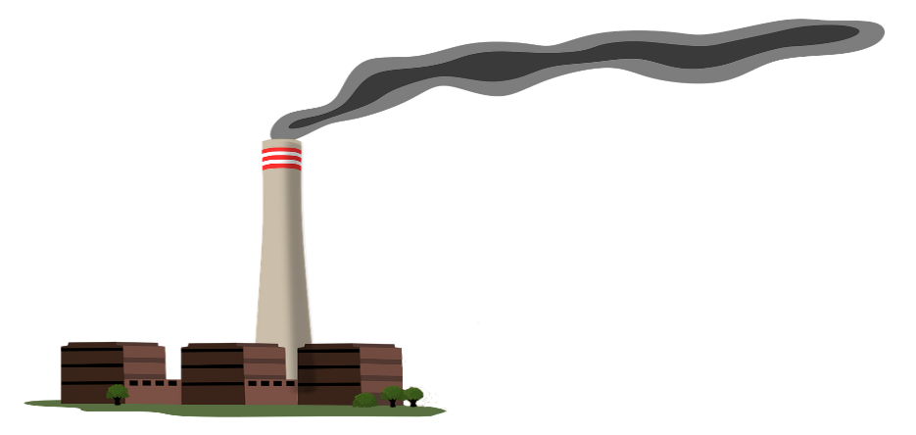
Power Plant

Air Pollutants
Sulfur Dioxide (SO₂)
Nitrogen Dioxide (NO₂)
Ground-Level Ozone (O₃)
Particulate Matter (PM)

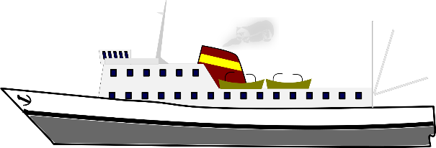
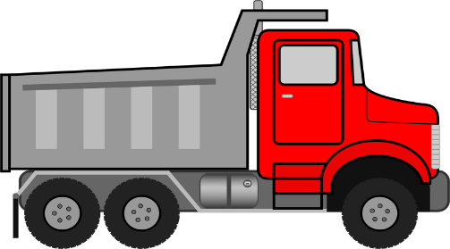

Transportation

Air Pollutants

Nitrogen Dioxide (NO₂)
Carbon Monoxide (CO)

Ground-Level Ozone (O₃)
Particulate Matter (PM)

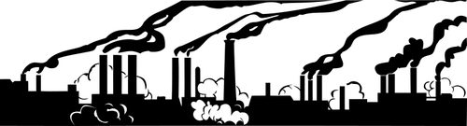
Manufacturing

Air Pollutants

Sulfur Dioxide (SO₂)
Ground-Level Ozone (O₃)
Particulate Matter (PM)
Lead

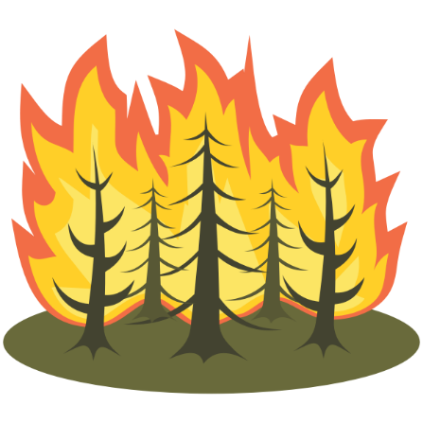
Natural Sources

Air Pollutants
Particulate Matter
Nitrogen Dioxide

