Name
STUDENT
ASSESSMENT

Our Lungs, Our Air, Our Health Module Assessment

Part 1: Organs of the Respiratory System

Directions: Use the word bank below to label the missing parts of the respiratory system in the diagram:
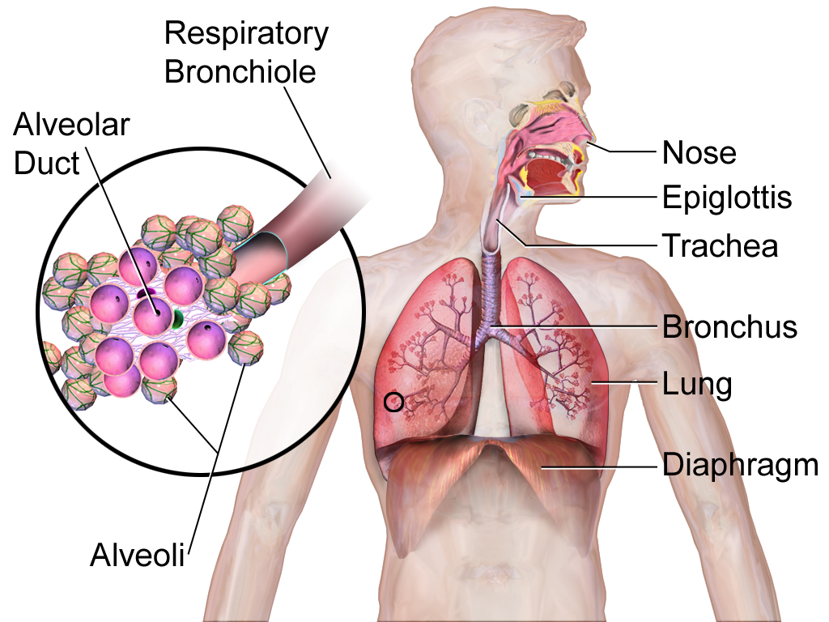

Word Bank

Lung Trachea Alveoli

Nose Bronchi
Part 2: The respiratory and circulatory systems

Directions: The simplified model below shows the human respiratory and circulatory systems. Use the model to answer the questions below.

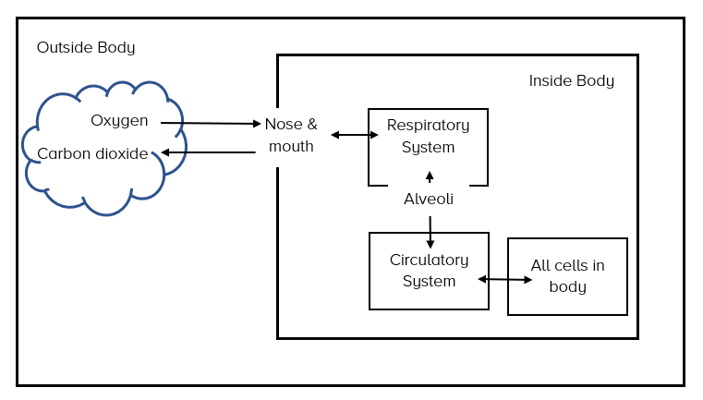

Use the model to explain the path of oxygen from the environment outside the body to the cells in your body. Make sure to include parts of the circulatory and respiratory systems in your answer.

Explain why the arrows in the model go in two directions inside the body.

Part 3: The Human Body: A System of Systems

The human body is called a system of interacting systems. Explain what this means in your own words. In your answer…

  - Briefly explain what a system is

  - Use at least one example from what you have done or learned in this unit to support your answer.

Part 4: Air pollution

Add ozone to the model below showing how it gets into the human body and what parts of humans it affects.

Add particulate matter 2.5 (PM 2.5) to the model below showing how it gets into the human body and what parts of humans it affects.

Air pollution can make asthma worse when humans breathe it in. Air pollution is a cause, and an asthma attack is the effect. Explain how air pollution can cause an asthma attack. You can use the diagram on the first page and the model on the second page to help with your answer.

